MongoDB -Aggregation Exercises

# Import the zips.json file into your MongoDB. Database name is "population" and collection name is "zipcodes".

# mongoimport --db population --collection zipcodes --file zips.json

**Atlanta Population**

# 1.use db.zipcodes.find() to filter results to only the results where city is ATLANTA and state is GA.

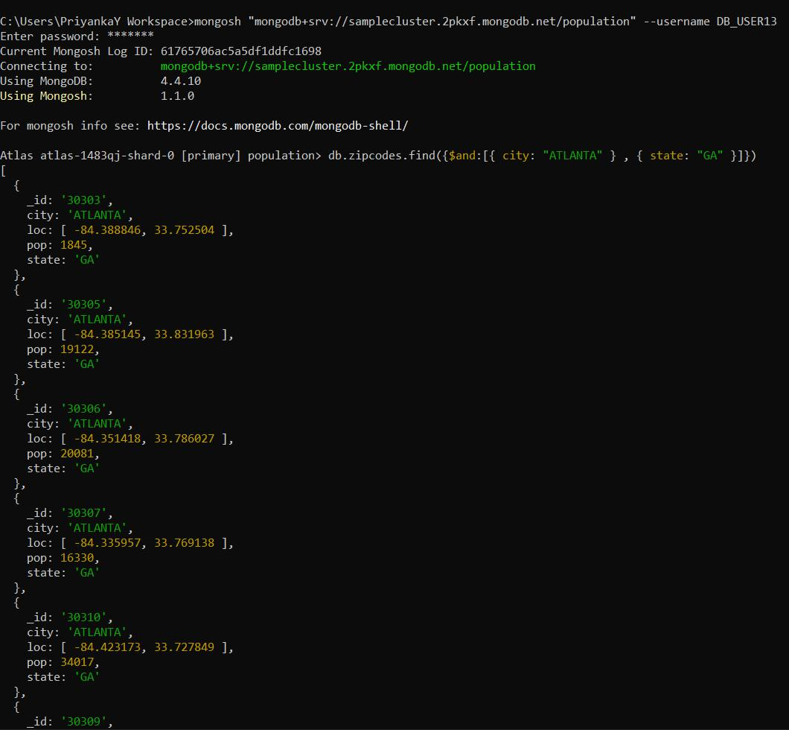

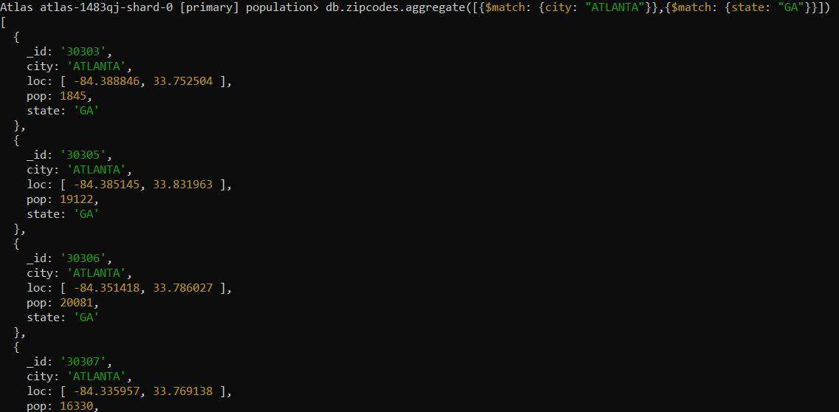2. use db.zipcodes.aggregate with $match to do the same as above.

# 3. use $group to count the number of zip codes in Atlanta.

# 

# 4. use $group to find the total population in Atlanta.

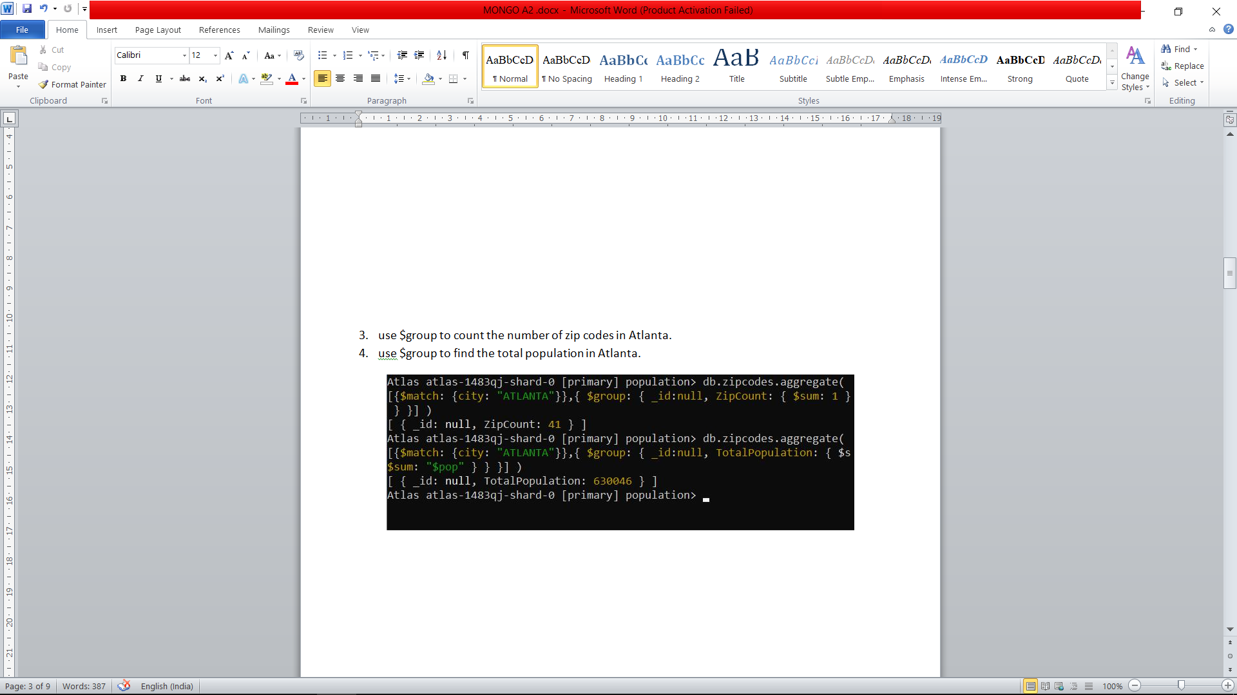

Populations By State

# 1. use aggregate to calculate the total population for each state

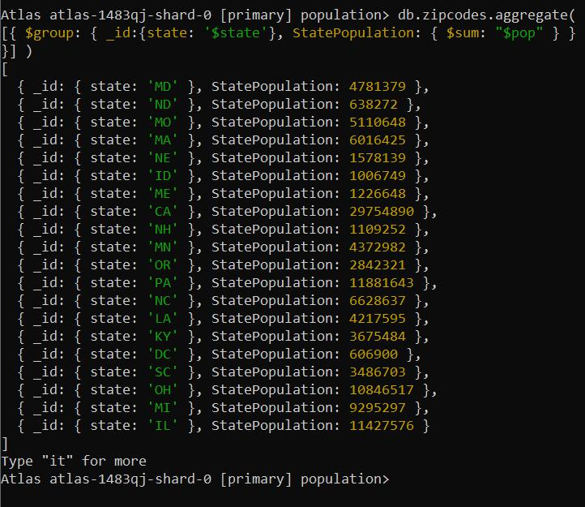

# 2.sort the results by population, highest first

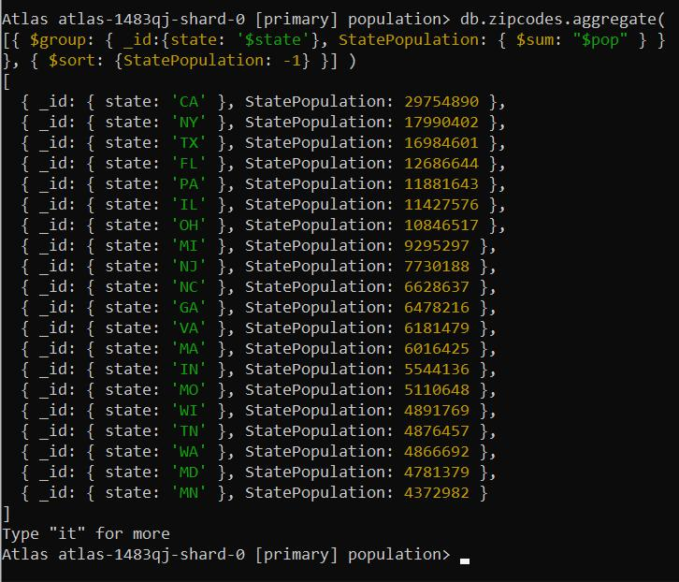

# 3.limit the results to just the first 3 results. What are the top 3 states in population?

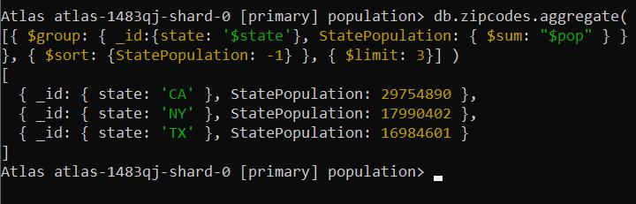

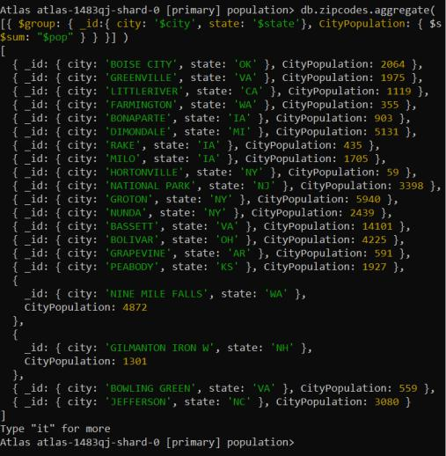

Populations by City

# 1. use aggregate to calculate the total population for each city (you have to use city/state combination). You can use a combination for the _id of the $group: { city: '$city', state: '$state' }

## 2.sort the results by population, highest first

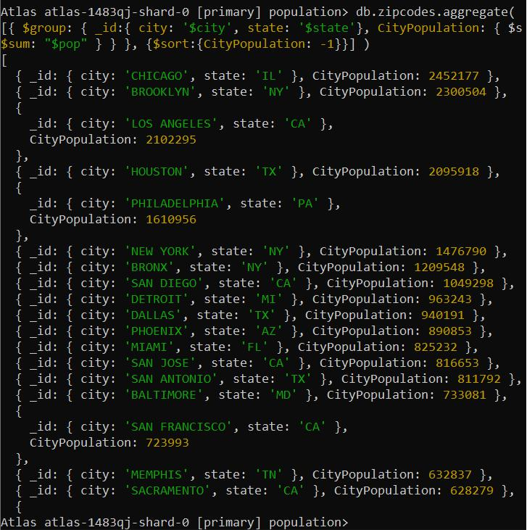

## 3.limit the results to just the first 3 results. What are the top 3 cities in population?

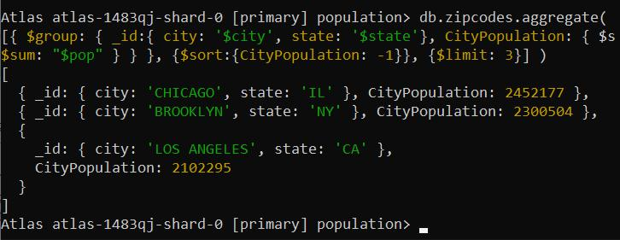

## 4.What are the top 3 cities in population in Texas?

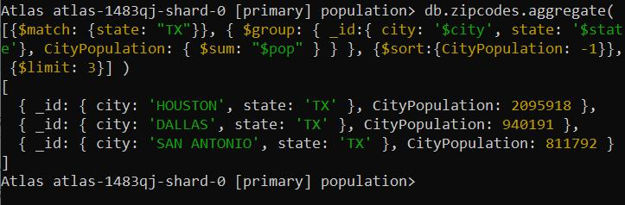

Bonus

# 1.Write a query to get the average city population for each state.

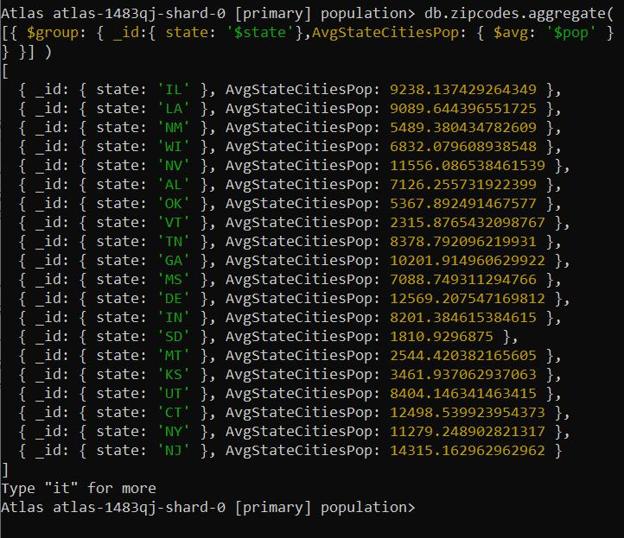

# 2.What are the top 3 states in terms of average city population?

